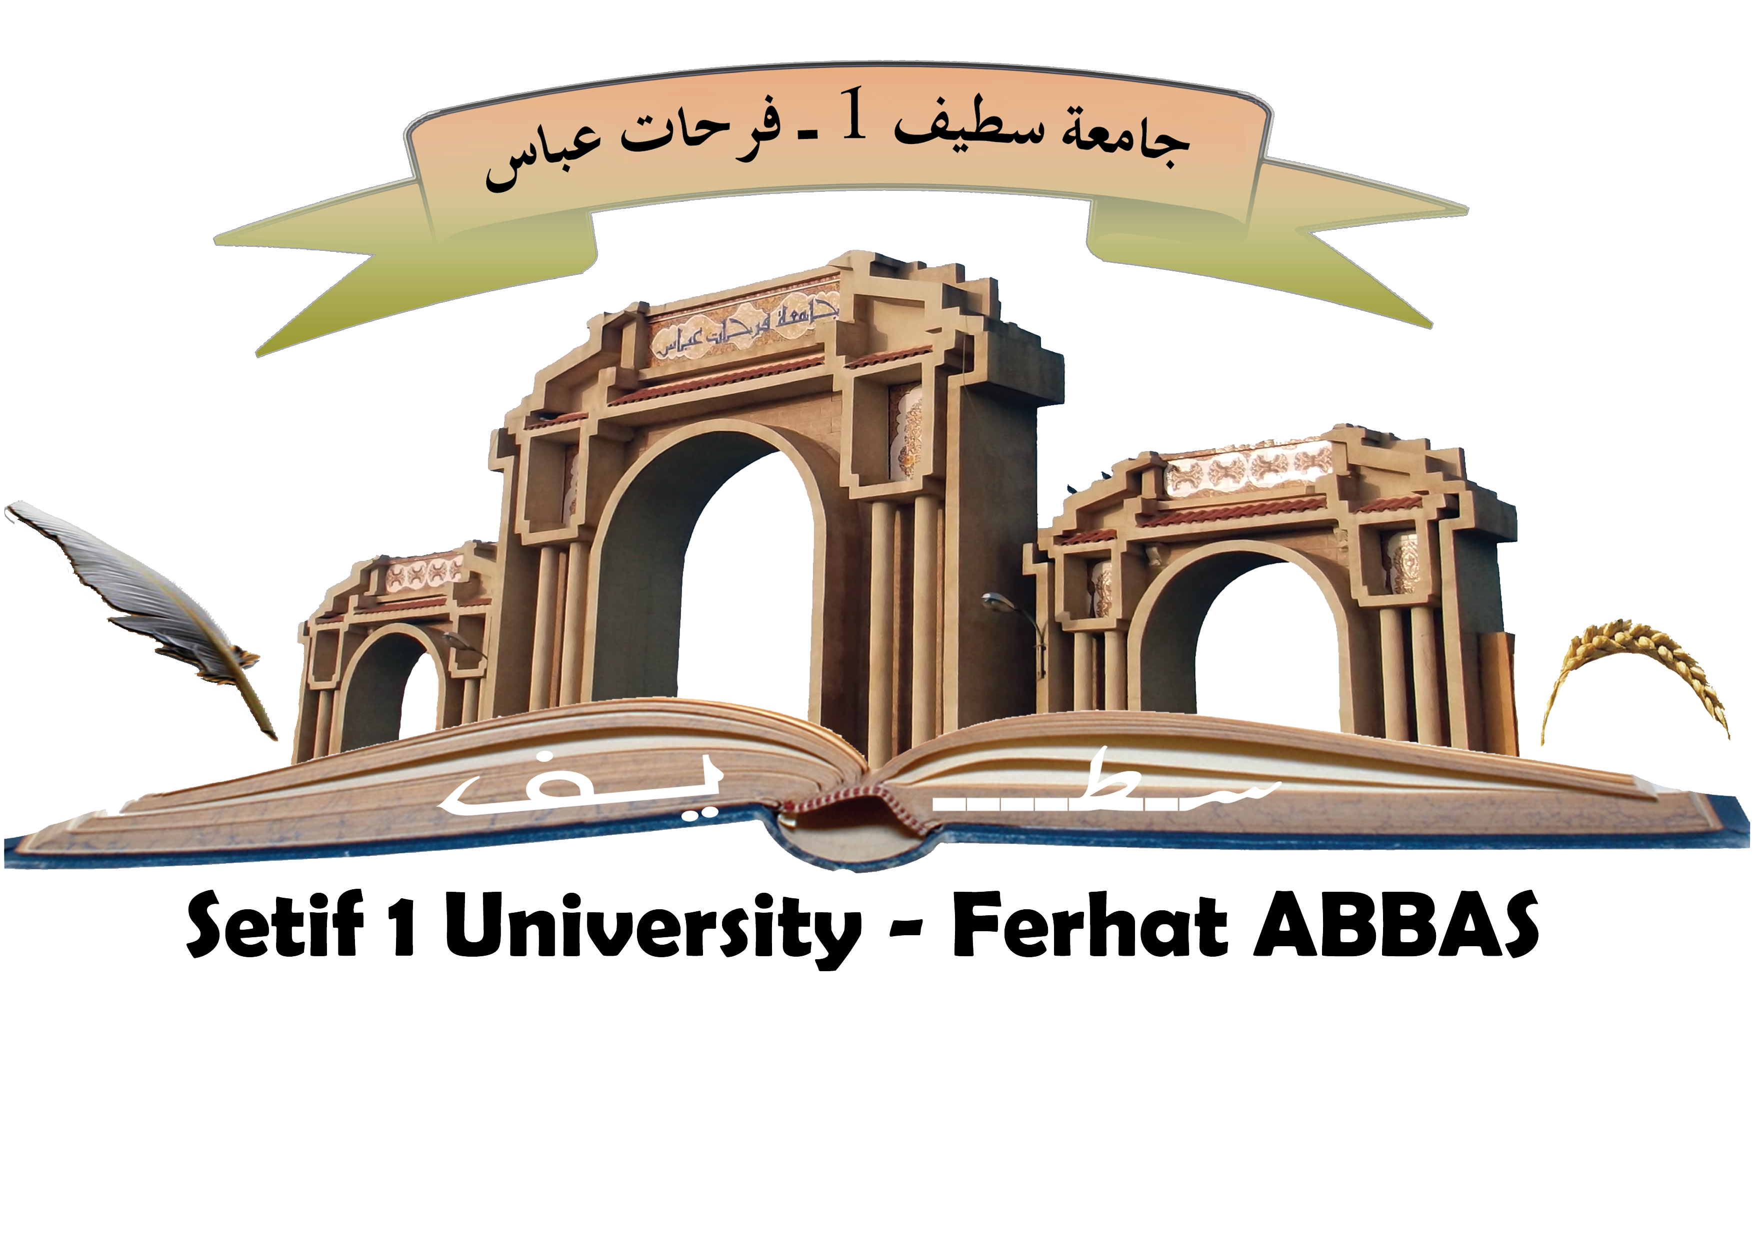

COOPERATION AGREEMENT
BETWEEN
FERHAT ABBAS SETIF 1 UNIVERSITY, ALGERIA
AND

…………………………………………………………………………………

Both parties to this cooperation hereinafter mentioned:
Setif 1 University Ferhat Abbas, located at El Bez campus, 19000 Setif- Algeria, represented by its Rector, Prof. Mohamed El Hadi LATRECHE …..

Acting under the powers conferred upon it, on the one hand
And
------------------------
Represented by
Acting under the powers conferred upon it, on the other hand
Hereinafter jointly referred to as “universities partners”,
Establish this general agreement to foster international cooperation in higher education and research,
Considering the legislative and regulatory provisions on cooperation in the fields of higher education and scientific and technical research between the Government of People's Democratic Republic of Algeria and ---------------------------------------------------------------
Considering the legislative and regulatory provisions regulating higher education and research in Algeria and-------------
Agree as follows:

Article 1: Partnership
In compliance with the laws and regulations in force in each of the institutions and their respective countries, "partner universities" agree to collaborate in the following areas:
- Exchange of teacher- researchers
- Exchange of students
- Exchanges of technical and administrative personnel as needed
- Development of joint formation programs
- Development of joint research programs
- Common direction of research work ( co-tutelage or co-supervision of theses)
- Facilitating access to scientific and pedagogical knowledge (exchange of publications and documentation)
- Joint organization of colloquiums, conferences, seminaries and short courses
- Other forms of cooperation: new educational products, e-learning, aid for the establishment of research fabric.

Exchange of staff and students will be mutually beneficial to both partners and broadly balanced.

Article 2: Scope of the Agreement
The cooperation may cover all common fields to both partners, exchanging annually any information and non-confidential documents in the purpose to realize, in the best conditions, the proposed cooperation and the exchange program.

Article 3: Conditions of application
The provisions in Articles 1 and 2 are jointly defined and are subject of specific convention annexed to this Agreement, according to the components and / or the disciplines concerned. These agreements specify the objectives, contents, staff involved and teaching modalities, administrative and financial procedures for implementing the cooperation bases and procedures for monitoring and evaluation.
The implementing agreements may be subject to regular updates if needed. They are signed by representatives of both partners.

Article 4: Exchange of Information
All information collected or exchanged within the cooperation and the search results or the techniques developed in common cannot be disclosed to third parties without the prior written consent of the partner universities.

Article 5: Intellectual Property
Each cooperation project in the field of research, university partners should ensure effective protection and equitable sharing of intellectual property rights.
Each partner university remains the sole owner of all intellectual property acquired previously or resulting from independent research.

Article 6: Means
This Agreement is concluded within the limits of available resources of both sides. To ensure the financing of exchange projects (equipment, operating, missions, training courses ...), the universities will request the allocation of resources from their respective departments, or from any external partner.

Article 7: Duration of the agreement
This agreement is in force for a period of five (05) years and shall become effective as the date of the last signature by either party, subject to approval by the competent authorities of each country if required.
Each partner may request the modification of the agreement; it will be performed as supplements established by mutual agreement between the partner universities.
The termination of the agreement may be requested by either partner with six months written notice. Activities in progress at the time of termination of this agreement shall be permitted to conclude as planned until the end of the academic year.
This Agreement may be extended once for a period of five years by either of the signatory institutions, given a six month notice. The renewal must be submitted to approval by the supervisory authorities if necessary.

Article 8: Dispute resolution
The partner universities shall try to resolve the totality of conflicts that occur during the signature or the execution of this agreement in a friendly manner.

Signed in Setif, on------- Signed in ------ (city), on---

Rector of Setif 1 University Ferhat Abbas Rector of -------- University
Professor Mohamed El Hadi LATRECHE Professor ---------

